Project 1: Search Algorithms

**Aims**: Get familiar with search algorithms in practice.

**Code examples**: http://aima.cs.berkeley.edu/code.html

**Todo list**: Implement the following algorithms:

**A1**. Breadth first tree search

**A2**. Depth first tree search

**A3**. Uniform-cost tree search

**A4**. A* tree search

**A5**. A* graph search

Generate search results for the following graphs (For Graph 1-3, we only need results of **A1-A2**; For Graph 4-5, we need results of **A1-A5**.)

**Project results**:

Outputs of all the nodes you dequeued from the fringe (considering the alphabetical order) for all the algorithms.

For the submission, you will need to include:

1. Your code in a zipped file
2. The output of all the results (dequeuing sequence)
3. Configuration: compiling system, programming language, how to run your program.

Graph 1：

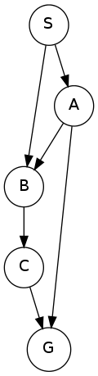

Graph 2：

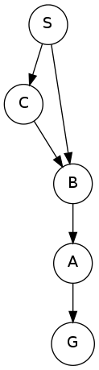

Graph 3：

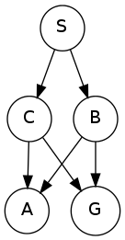

Graph 4：Output the sequence stopped by getting one of the gold state (G1 or G2). Arcs are labeled with the action costs (lower is better) and heuristic values to a goal are reported inside nodes. If there is loop in the output, please stop after three loops.

Graph 5：Arcs are labeled with action costs and states are labeled with heuristic values.

